**The Fourth Branch Website**

**Technical Specifications**

**Phase 2**

Table of Contents

Overview 3

New Site Features 4

1.0 – District Search Capability 4

Feature Function 4

2.0 – PayPal Donation Capability/Contribute Page 7

Feature Function 8

3.0 – Multiple Bill Type Support Functionality 8

Feature Function 9

4.0—Wall of America 13

Feature Function 13

5.0 – All Votes View 15

Feature Function 15

Approval 19

# Overview

The Fourth Branch is a website dedicated to creating political transparency around the activities of local politicians through the disbursement of knowledge on their various votes as well as how those votes synch up with their constituencies. The hope is that through the site, Americans can become more politically astute and therefore play a more prominent role in political proceedings as well as bill creations. The site seeks to do this by displaying current bills as well as potential bills (proposals) under consideration and allowing users to vote (yes or no) on whether they approve of the bill as well as comment on the bill to allow for website community dialogue. In a sense, Fourth Branch is a political social networking site. Users, which can be individuals or corporations, will be allowed to see the aggregation of site votes based on pre-determined criteria (gender, age etc.). Users will be allowed to follow other users through functionality similar to the Facebook “like” process.

All of the above functionality was implemented in phase one of this initiative. This technical specifications document will address all of the features and functionality necessary for phase 2 of the site from a functional/technical perspective.

# New Site Features

The new list of features for the site is as follows:

1. District Search Capability
2. PayPal Donation Capability
3. Multiple Bill Type Support Functionality
4. Wall of Wishes
5. All Votes View

All features are visible to both registered users as well as non-registered users, however, the actions behind these features e.g. voting on a bill, submitting a summary, viewing statistics etc., will be limited to registered users that have logged in to the system. Anyone that has not logged into the system that attempts to perform an action related to a feature, will be notified that they have not logged into the system and would need to do that in order to participate at that level or would need to register in order to have access to this type of functionality.

# 1.0 – District Search Capability

Currently the registration functionality on the Fourth Branch web site allows users to register at a city and state level. This level is not granular enough to display to a user the exact representative as these are assigned at a district level.

## Feature Function

Once a user enters an address, the system will capture the following pieces of data:

1. street
2. city
3. state
4. ZIP

The values for state will be based off of the format used at the house.gov website and thus will be as follows:

<option selected value="00??">Select a State</option>

<option value="ALAlabama">Alabama</option>

<option value="AKAlaska">Alaska</option>

<option value="ASAmerican Samoa">American Samoa</option>

<option value="AZArizona">Arizona</option>

<option value="ARArkansas">Arkansas</option>

<option value="CACalifornia">California</option>

<option value="COColorado">Colorado</option>

<option value="CTConnecticut">Connecticut</option>

<option value="DEDelaware">Delaware</option>

<option value="DCDistrict of Columbia">District of Columbia</option>

<option value="FLFlorida">Florida</option>

<option value="GAGeorgia">Georgia</option>

<option value="GUGuam">Guam</option>

<option value="HIHawaii">Hawaii</option>

<option value="IDIdaho">Idaho</option>

<option value="ILIllinois">Illinois</option>

<option value="INIndiana">Indiana</option>

<option value="IAIowa">Iowa</option>

<option value="KSKansas">Kansas</option>

<option value="KYKentucky">Kentucky</option>

<option value="LALouisiana">Louisiana</option>

<option value="MEMaine">Maine</option>

<option value="MDMaryland">Maryland</option>

<option value="MAMassachusetts">Massachusetts</option>

<option value="MIMichigan">Michigan</option>

<option value="MNMinnesota">Minnesota</option>

<option value="MSMississippi">Mississippi</option>

<option value="MOMissouri">Missouri</option>

<option value="MTMontana">Montana</option>

<option value="NENebraska">Nebraska</option>

<option value="NVNevada">Nevada</option>

<option value="NHNew Hampshire">New Hampshire</option>

<option value="NJNew Jersey">New Jersey</option>

<option value="NMNew Mexico">New Mexico</option>

<option value="NYNew York">New York</option>

<option value="NCNorth Carolina">North Carolina</option>

<option value="NDNorth Dakota">North Dakota</option>

<option value="MPNorthern Mariana Islands">Northern Mariana Islands</option>

<option value="OHOhio">Ohio</option>

<option value="OKOklahoma">Oklahoma</option>

<option value="OROregon">Oregon</option>

<option value="PAPennsylvania">Pennsylvania</option>

<option value="PRPuerto Rico">Puerto Rico</option>

<option value="RIRhode Island">Rhode Island</option>

<option value="SCSouth Carolina">South Carolina</option>

<option value="SDSouth Dakota">South Dakota</option>

<option value="TNTennessee">Tennessee</option>

<option value="TXTexas">Texas</option>

<option value="UTUtah">Utah</option>

<option value="VTVermont">Vermont</option>

<option value="VIVirgin Islands">Virgin Islands</option>

<option value="WAWashington">Washington</option>

<option value="WVWest Virginia">West Virginia</option>

<option value="WIWisconsin">Wisconsin</option>

<option value="WYWyoming">Wyoming</option>

These values will be used to make an HTTPRequest that will mimic the request made on house.gov. The request will look as follows:

[http://www.house.gov/htbin/findrep?ADDRLK31154111031154111&street=[entered](http://www.house.gov/htbin/findrep?ADDRLK31154111031154111&street=%5bentered) street address]&city=[entered city address]&state=[entered state value based on drop down above]&ZIP=[entered ZIP value]

This request will return the information on the representative for the user. The exact rep name will have to be extracted from the HTML page by creating a regular expression to identify the following code snippet:

<p class="rep color2"><img src="/zip/pictures/ny13_rangel.jpg" alt="" border="0" class="repPhoto" />

<a href="http://rangel.house.gov/">Charles B. Rangel </a>

and extracting the name between the HTML code pattern.

# 2.0 – PayPal Donation Capability/Contribute Page

The PayPal interface caters for non-profits accepting donations but not for profits. To bypass this process, the system will need to be able to make purchases of good will at $1/per offering to facilitate the mimicking of a donation process without breaking any of PayPal’s rules. The system should be able to work like an online shopping cart and users will receive an email confirmation at the end of the transaction.

## Feature Function

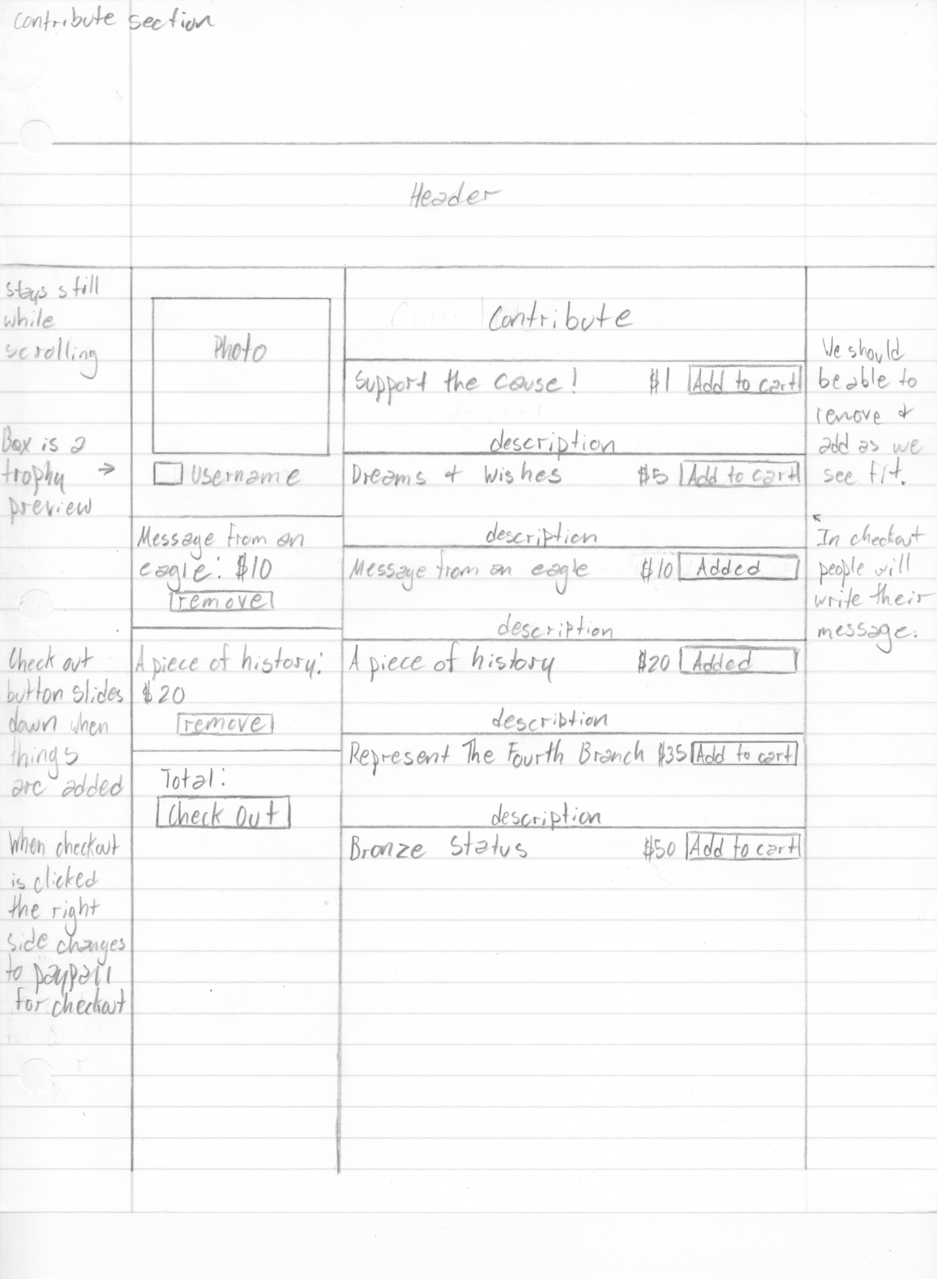

These buttons only trigger a change in the visuals for the shopping cart column on this page and doesn’t really trigger PayPal functions. Must be used to add to aggregate request for eventual PayPal checkout though.

This Check Out will aggregate PayPal button “Add to Cart” commands and send full request to PayPal where user will complete payment transaction. After payment is completed, user will be returned to this page.

# 3.0 – Multiple Bill Type Support Functionality

The current site supports regular bills. The site needs to be expanded to support the following types of bills:

1. Regular Bills
2. Large Bills
3. Appropriations Bills

## Feature Function

New data fields (beyond standard bill) are as follows:

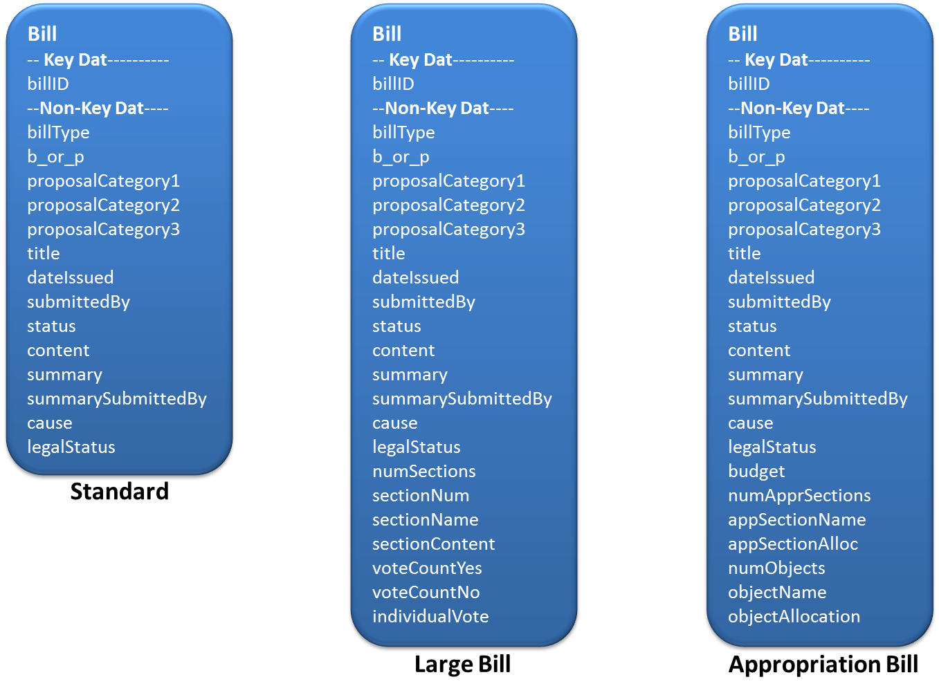

**Wireframes:**

The following are basic wireframe mockups of the large bill and appropriation bill:

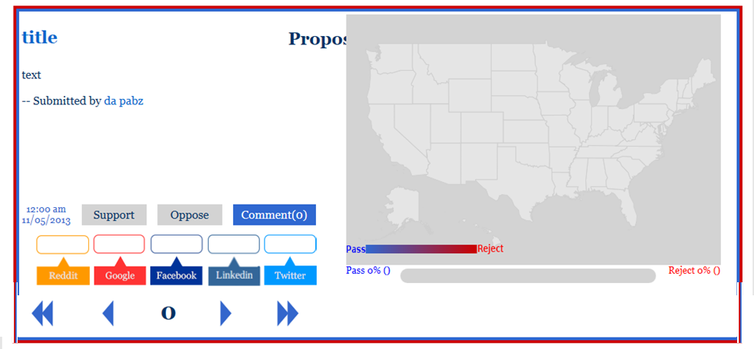

Figure 1 -- Large Bill wireframe

A large bill looks exactly like a small bill but has arrows to direct the user through the different sections.

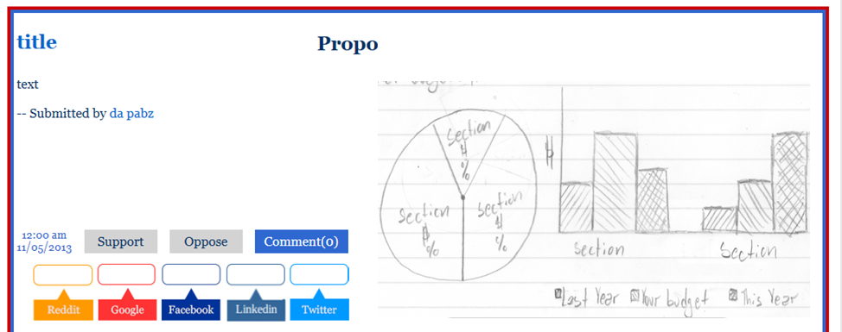

Figure 2 -- Appropriations Bill Wireframe 1

Appropriations bills exist only on the Vote page (never on the homepage). It would look like a normal bill with the bill name, code, text, timestamp, share buttons, comments etc. however there would be no vote feature. On the right, where there would normally be the map, would be a darkened version of the pie chart and bar graph shown in above. Those would end up being colored once a user actually does the appropriations process i.e. click the bill to enter the page.

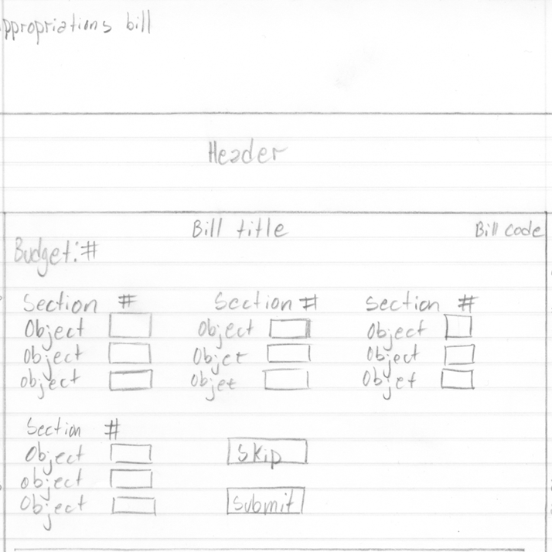

Figure 3 -- Appropriations Bill Wireframe 2

Once on the Appropriations bill page, they would only see the page above. They would see the bill title, bill code, and budget which would show the $ amount and % (which will be input from the admin side). The user will then be prompted to distribute by % (must add up to 100%), the amount they think should go to every "section" of the appropriations bill e.g. they can say 10% to army, 90% to air force. Once they click submit, every "section" will reveal objects that the user then has to apportion a % of their money towards e.g. say they are looking at army, they gave 10% of the total military budget to army that is one billion dollars. Now they have to give by % amounts to tanks, uniforms, rifles, etc. At the end of all of the objects will be save functionality. Users will also have the ability to change an allocation amount and resave.

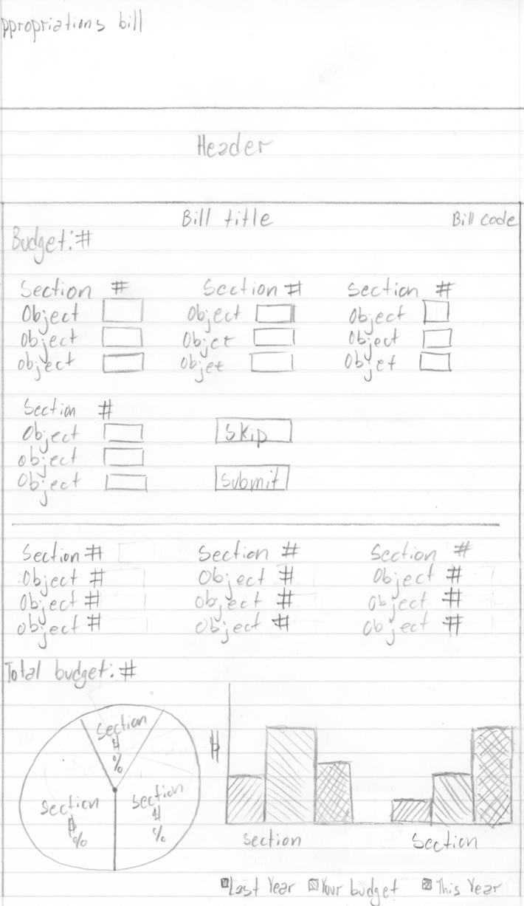

Figure 4 -- Appropriations Bill Wireframe 3

Once the entire form is completed, users will be able to click submit. A pie chart should be generated showing how the user allocated the money in the sections. Once the user clicks submit the "actual" numbers will also be displayed below with the graphs and charts (see Figure 4). If a user clicks skip then basically it will automatically display the information on the bottom half of the screen, except the bar graph would take away the "your budget" for the sections. Once a user either fills this out, or chooses to skip and see the results, if you go back on the Vote page, the graphs next to the appropriations will be the appropriate ones and they will be colored. Pie chart should be colorful, and same with bar graph.

**Application Logic:**

Allocations must add up to 100%.

# 4.0—Wall of America

Users that have donated to the Fourth Branch will be allowed to post their wishes up on a Wall of America. This page will display user wishes as well as the submitter’s name in a chronological format. Content on the wall will be pushed down as more wishes go up on the wall but all wishes will remain visible on the wall and will not be removed over time.

### Feature Function

The access point for this feature is off of the home page. Thus the home page will look more like the following:



Once on the page, the wireframe of the page is as follows:

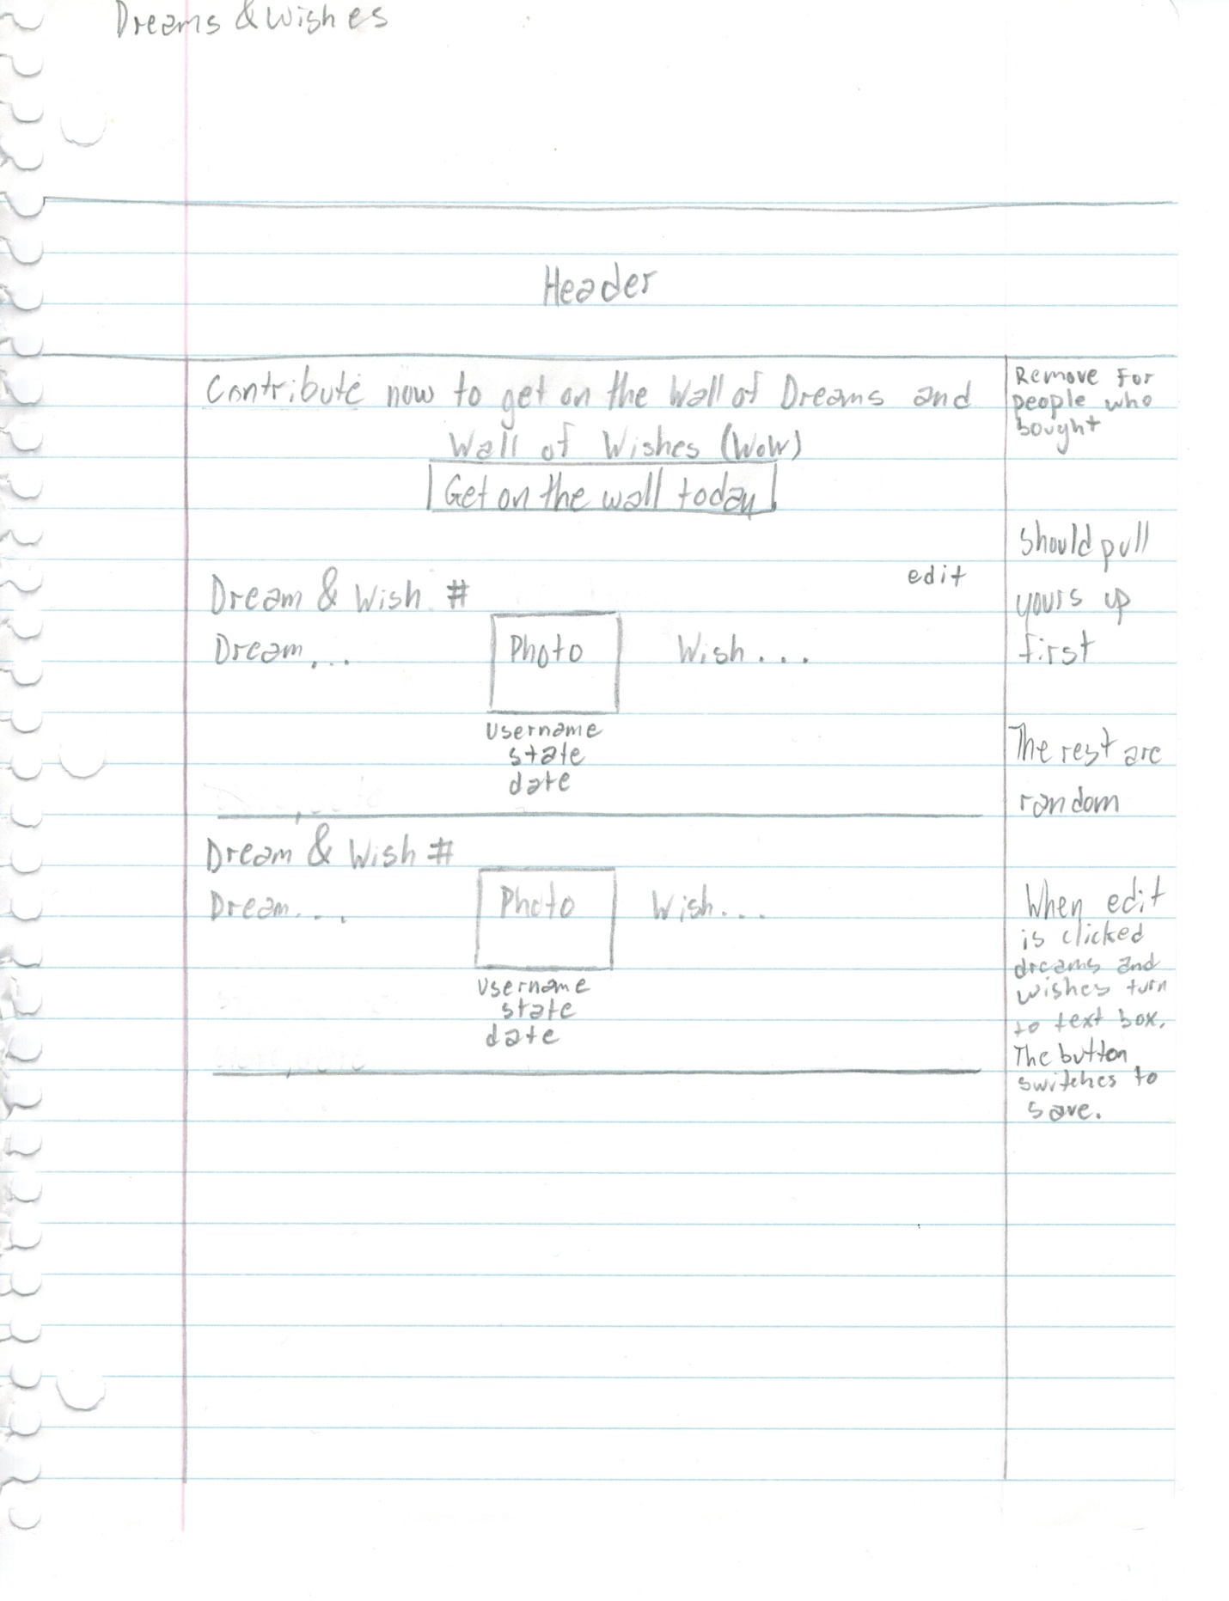

Figure 5 -- Wall of America Wireframe

As alluded to in Figure 5, at the top of the page will be some writing to promote contribution and then a button that basically takes people to the store and automatically adds the wall of dreams and wishes to their cart and prompts them to checkout automatically. The dream and wish number is a static number that will be generated according to the number of posts. The text on the left and right of the picture and information will be the text of the individual. The date posted will just be a standard time stamp, and the state will be the state from which the person posted. The first post on the wall if a user is signed in will basically be their post, and there should be a little edit button in the top left corner. We want to allow people to edit their dreams and wishes at any point in time so when they go on the wall the first thing they will see is this. Then once they edit their post, on the bottom left of their box should be a save button that will allow them to save their changes. If a user has already purchased the feature, then there will not be a button promoting them to buy this feature at the top of the page. If a person visits this page and is not signed in then they get to see the entire page, however they will not have their post first. They will still have the option to buy the feature, but it should prompt them to sign up first before purchasing it. If a "dream" is longer than a "wish" then as a user is scrolling and reading the dream, the wish section will also continuously move down along with the middle section of every users post. This is an infinitely expanding wall as people post stuff until users reach the bottom of the page where it is the standard footer. If a user has not logged in and clicks the “Contribute” button on the page, they will have the option to log in.

The site administrator will have a similar page to input filler wishes & dreams until users actually use the functionality.

# 5.0 – All Votes View

Users should have the ability to view all of the votes that they have made while being in the Fourth Branch system.

### Feature Function

The wireframe for the page is as follows:

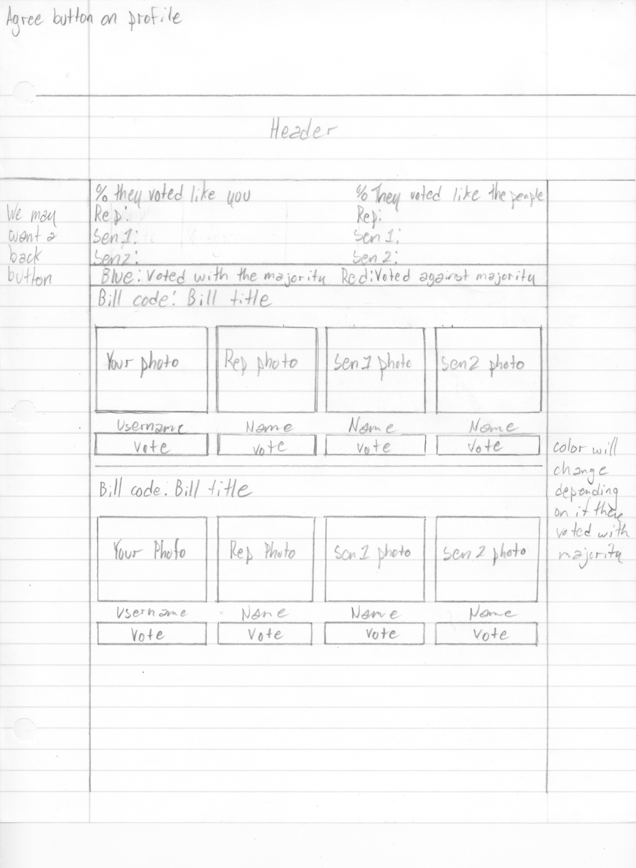

Figure 6 – Vote History Wireframe

The All Votes view is accessible on a user’s profile page. Instead of the word FOLLOW, if a user is looking at his/her own page, it will say VOTE HISTORY. Once clicked All Votes page comes up. The features will be as follows:

1. At the very top it should say the Congress # (Congress 113) so as to shows people which Congress they are looking at the votes for. As time progresses this page will track how people are voting across congress lines. So say 50 years from now, at the top of this page, it will say Congress 113, Congress 114 etc. All of these will be clickable and will display different data when clicked. Basically a way for people to keep track of all of their things using this feature over time.
2. Then we have your representatives from that Congress and the % number of times that they voted like you overall for the duration of that Congress' life. The second column on the right shows the % of times that the representatives voted like their constituents (basically like the majority of their state or district depending on if we are talking about a house representative or senator).
3. After the key which will just be blue and red with the description (as in Figure 5), we want to have a SEARCH bar between that and the first bill history. Users will be able to use the search bar the same exact way as it is in the VOTE page except without all of those filters on top, but the actual search algorithm would function the same way.
4. If a user goes onto this page and their representative has not voted on an issue then the representatives vote will say, “has not voted yet”, and those statistics will not be calculated to the top bar statistics.
5. Under every Reps photo should be their name, email address or link to website (some reps do not have an email and so they make people go through their website to message them), phone number and vote.
6. Users will just be able to scroll and see the votes of representatives on this page, and they can use the search feature to look up something specific if they wish to do so otherwise everything is placed by time on the page.
7. If a user clicks on email the rep we want an email service to automatically open up and let the person sign in. Once they sign in, the email address of the rep is automatically there and they can type in their message.
8. For the phone number - can we incorporate Google phone or some other free telephone service to allow people to call their representatives right then and there?
9. Whenever a user emails or calls a representative by clicking the link we want to help "guide them". We wanted a little box to appear that would basically follow this format and pull data from the page to help people phrase what they want to say to the rep.

Hello (Rep name),

I (Actual first and last name of person) from (state and district number) (oppose OR support) (Bill code) (Bill title).

The administrator will need to be able to upload information of representatives and to say which congress they belong to. Representatives will be stored as “Users” in the database but will be of type “Representative” or “Senator” and thus will have a subset of features to support tracking votes, storing pictures etc. They will need to be able to select congress, input info on a representative belonging to that congress and to make the congress active i.e. all votes going forward that become CLOSED will have the information displayed about the congressmen.

# Approval

This document has been approved as the official Technical Specifications Document for the Fourth Branch website. Following approval of this document, changes will be governed by the project’s change management process, including impact analysis, appropriate reviews and approvals, under the general control of the Master Project Plan and according to Project Support Office policy.

|  |  |  |
| --- | --- | --- |
| Prepared by | Signature | Date |
| Brennon Marcano  Executive Director  WOS |  |  |
| Approved by | Signature | Date |
| Leo Levit  CEO  The Fourth Branch |  |  |
|  |  |  |